Jayne Bormann
Homework Lectures 4-5 revised
April 5, 2011

Problem 7: How large is the largest equilibrium tide on Earth?

$V={\text{GM}}_{\text{Moon}}\left(\frac{1}{d}−\frac{1}{s}−\frac{r_{\text{earth}}\text{cos}y}{s^{2}}\right)$= 3.57 m² s⁻²
$dN=\frac{V}{g_{\text{earth}}}$ = 0.36 m

The largest equilibrium tide on earth is the diurnal lunar (M2) tide. The amplitude of this tide is about 0.36 m.
5

Problem 9: How large is the tidal bulge of the Moon?
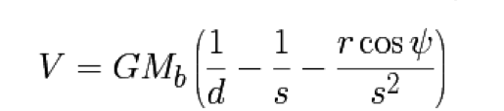
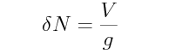
G = 6.673•10⁻¹¹ m³ kg⁻¹ s⁻²
M_{moon} = 7.35*10²² kg
M_{earth} = 5.97*10²⁴ kg
d = 382664900 m (distance between surface of the moon and center of the earth)
s = 384,403 kilometers = 384403000 m (distance between the center of the moon and center of the earth)
r_{moon} = 1738.1 km = 1738100 m
r_{earth} = 6378.14 km = 6378140 m
ψ = 0 (assume that the tide is at it’s maximum when the body is directly overhead)
g_{moon} = (G* M_{moon})/ r_{moon}² = 1.62 m s⁻²

$V={\text{GM}}_{E}\left(\frac{1}{d}−\frac{1}{s}−\frac{r_{\text{moon}}\text{cos}y}{s^{2}}\right)$ = 21 m² s⁻²
$dN=\frac{V}{g_{\text{moon}}}$ = 13 m

The tidal bulge of the moon is approximately 13 m.
5

